
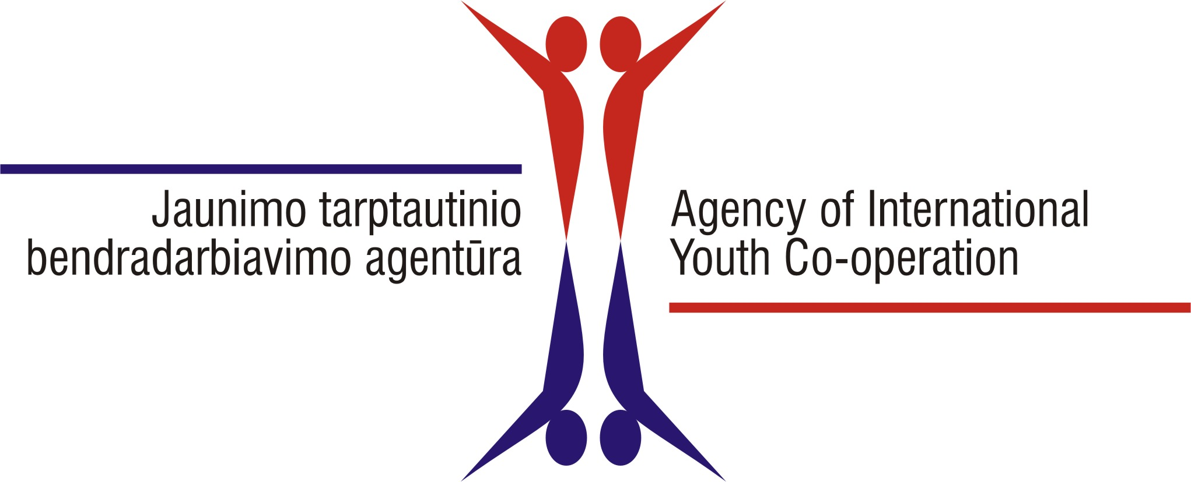
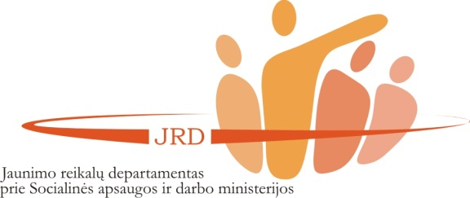

International Scientific-Practical Conference
“DO I KNOW YOUNG PEOPLE?”

27th September, 2012
Vilnius University
Faculty of Philosophy, Universiteto str. 9/1, room No. 201

Programme of the second day of the conference

Moderator: Assoc. prof. dr. Jolita Buzaityte-Kasalyniene
Participants: conference presenters and invited representatives from youth policy making institutions and practitioners.
Language: English

9.00-10.30 | Feedback from parallel sessions of the first day.  Presentation of the main themes/ ideas which have been raised in parallel sessions of the conference.  Presentations by moderators with following discussion in a whole group
10.30-11.00 | Coffee break
11.00-13.00 | Panel discussion “Cooperation between youth policy makers, researchers and practitioners”  Questions for the discussion:  What are my experiences of cooperation between youth policy makers, researchers and practitioners? What results were achieved by the cooperation? What were the factors promoting cooperation and what were the pitfalls/ difficulties/ issues for it? What are the future plans/ perspectives?  How do I think, what are expectations for the cooperation held by different parties, e.g., what policy makers are expecting from researchers and vice versa? What practitioners are expecting from policy makers and vice versa, etc.  5-6 presentations 10 min each, followed by questions for presenters and joint discussion in a whole group.
13.30-14.30 | A guided tour at Vilnius University, optional, will be held in English.

