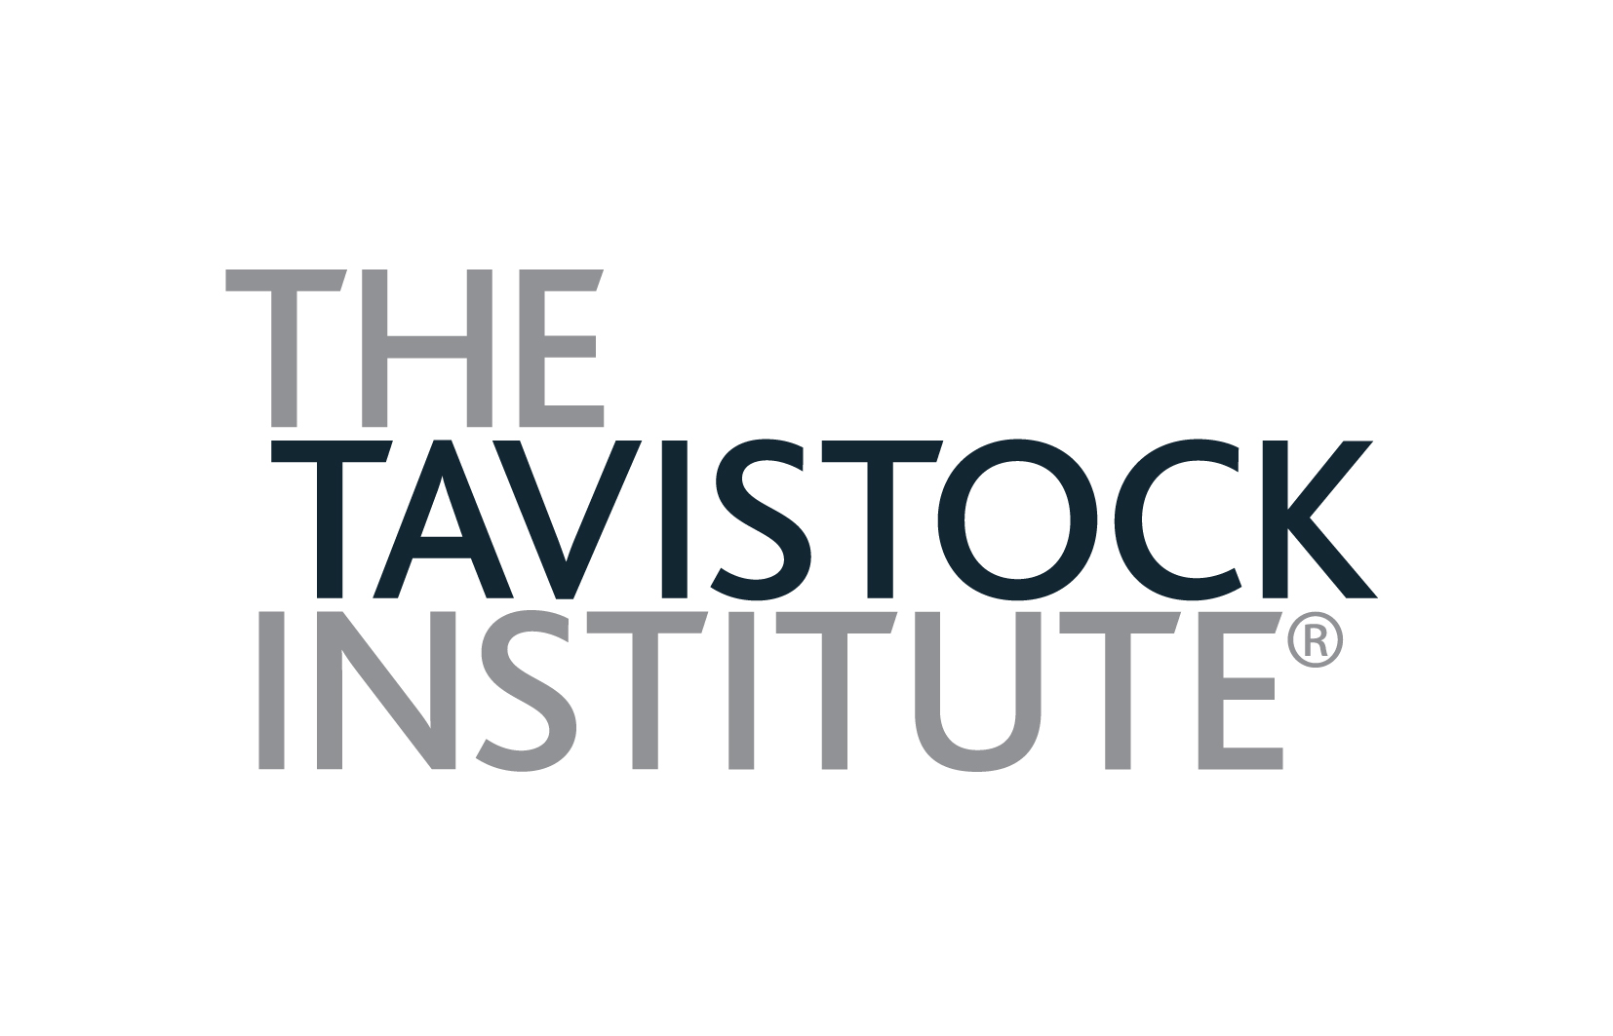

VILNIUS UNIVERSITY
and
THE TAVISTOCK INSTITUTE OF HUMAN RELATIONS

A LIGHT IN THE SHADOW OF HISTORY:
LEADERSHIP & IDENTITY IN ORGANISATIONS & COMMUNITIES
28th June – 2nd July 2014

APPLICATION FORM

Please fill in the information requested below

Surname: ………… ………………………………….………Title: Mr / Ms / Mrs / Dr

Forename(s) …………… ………………………………...…..Age: …………….…..…….

Male / Female ……………………..Nationality……………………………………………

Employing Organisation ………………………………………..…………………………….

Official Title of Present Post: …………………………………….…………………………..

Type of Employing Organization: Private/ Governmental/ NGO (non-profit)

Previous experiences in Group Relations (please specify)………………………

………………………………………………………………………………………….

…………………………………………………………………………………………..

Private mobile: ……………………….. Email: …………………………………………

I would like to apply for Progression Sub-conference…………….Yes/No

I would like to apply for Progression Sub-conference because (please give your
reasons) …………………………………………………………………………………………………
…………………………………………………………………………………………………………..
………………………………………………………………………………………………………….
………………………………………………………………………………………………………….
…………………………………………………………………………………………………………..
…………………………………………………………………………………………………………..
Please note, that acceptance to the Progression sub-conference is not automatic, but will be decided by the Directorate.

To reserve your place:

Please return this application form to:

Erika Speicyte-Ruschhoff
E: grupiusantykiai@gmail.com
T: +370 61064223 (Erika)
T: +370 68228208 (Jolita)

The conference fee must accompany your application form and it must be received by 9th June 2014 (deadline for applications). Applications received by 9th May 2014 will attract the Early-bird discount of 300 Litas. A University receipt confirming your payment will be sent to you by email.

If you are applying for a bursary, please send your request to Erika Speicyte-Ruschhoff. You will be asked for additional information.

I confirm that I have read the brochure for this programme and I am applying to become a member of the programme. I understand that this brochure constitutes the contract between the University of Vilnius and myself and that my application authorizes the University to conduct the programme in the manner described.

Signature of applicant: …….…..…………….…..................... Date: ……………………

