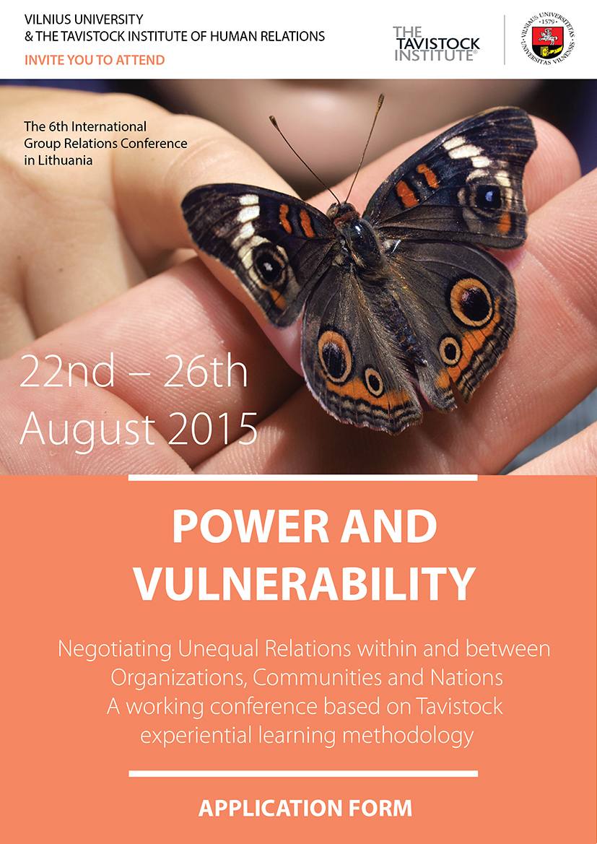

Please fill in the information requested below

Surname: ………… ………………………………….………Title: Mr / Ms / Mrs / Dr

Forename(s) …………… ………………………………...…..Age: …………….…..…….

Male / Female ……………………..Nationality……………………………………………

Employing Organisation ………………………………………..…………………………….

Official Title of Present Post: …………………………………….…………………………..

Type of Employing Organization: Private/ Governmental/ NGO (non-profit)

Previous experiences in Group Relations (please specify)………………………

………………………………………………………………………………………….

…………………………………………………………………………………………..

Private mobile: ……………………….. Email: …………………………………………

To reserve your place:

Please return this application form to:

Milda Autukaite
E: grupiusantykiai@gmail.com
T: +370 68214307 (Milda)
T: +370 68228208 (Jolita)

The conference fee must accompany your application form and it must be received by 17th July 2015 (deadline for applications). Applications received by 12th June 2015 will attract the Early-bird discount of 80 EUR. A University receipt confirming your payment will be sent to you by email.

If you are applying for a bursary, please send your request to Milda Autukaite. You will be asked for additional information.

I confirm that I have read the brochure for this programme and I am applying to become a member of the programme. I understand that this brochure constitutes the contract between the University of Vilnius and myself and that my application authorizes the University to conduct the programme in the manner described.

Signature of applicant: …….…..…………….…..................... Date: ……………………

