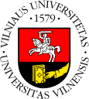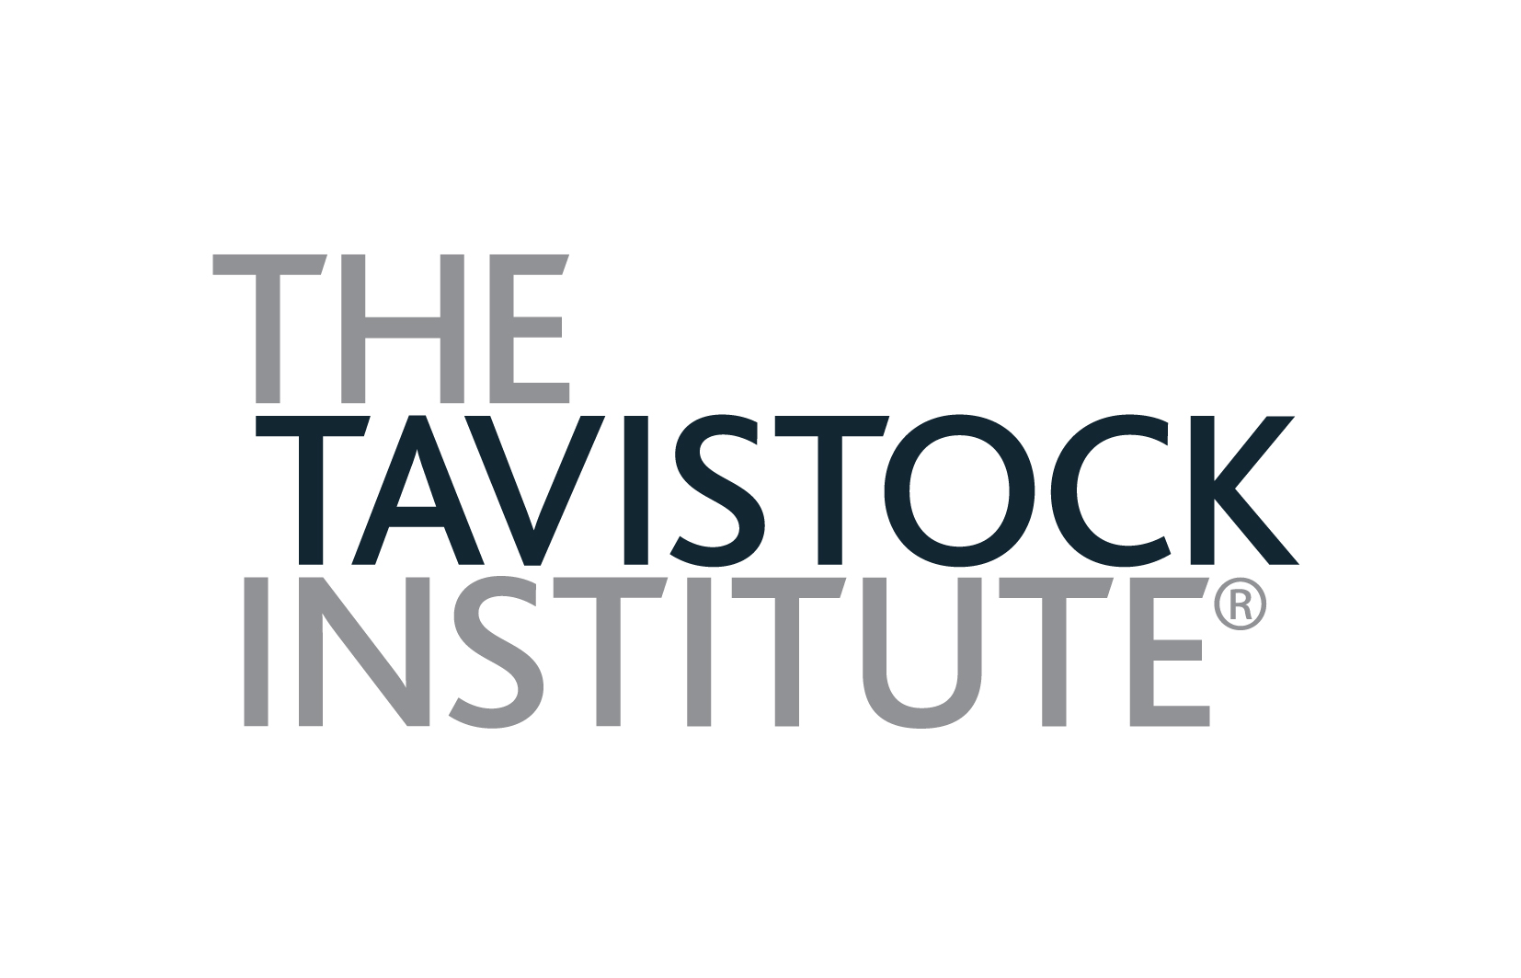

VILNIUS UNIVERSITY
and
THE TAVISTOCK INSTITUTE OF HUMAN RELATIONS

International Group Relations Conference

Re-imagining Leadership and Authority

18th – 22nd August 2017
Vilnius

APPLICATION FORM

Please fill in the information requested below

Surname: ………… ………………………………….………Title: Mr / Ms / Mrs / Dr

Forename(s) …………… ………………………………...…..Age: …………….…..…….

Male / Female ……………………..Nationality……………………………………………

Employing Organisation ………………………………………..…………………………….

Official Title of Present Post: …………………………………….…………………………..

Type of Employing Organization: Private/ Governmental/ NGO (non-profit)

Previous experiences in Group Relations (please specify)………………………

………………………………………………………………………………………….

…………………………………………………………………………………………..

Private mobile: ……………………….. Email: …………………………………………

To reserve your place:

Please return this application form to:

Tomas Rakovas
E: grupiusantykiai@gmail.com
T: +370 67806610 (Tomas)
T: +370 69883434 (Jolita)

The conference fee must accompany your application form and it must be received by 17th July 2017 (deadline for applications). Applications received by 3rd June 2017 will attract the Early-bird discount of 80 EUR. A University receipt confirming your payment will be sent to you by email.

If you are applying for a bursary, please send your request to Tomas Rakovas. You will be asked for additional information.

I confirm that I have read the brochure for this programme and I am applying to become a member of the programme. I understand that this brochure constitutes the contract between the University of Vilnius and myself and that my application authorizes the University to conduct the programme in the manner described.

Signature of applicant: …….…..…………….…..................... Date: ……………………

